Use-Case Realization Report
Add Outline

Issue <1.0>
Revision History
Date | Issue | Description | Author
12./10/09 | 1.0 | Initial Version | Rajendran Kumaraguru

Table of Contents
1. Brief Description 4
2. Flow of Events 4
2.1 Standard Flow 4
2.2 Exception Flow 4
3. Interaction Diagrams 4
3.1 Collaboration Diagram for Add Outline 4
4. Participating Objects 5
5. Class Diagrams 5
5.1 Class Diagram for Add Outline 5
6. Derived Requirements 5

Use-Case Realization Report
Add Outline

Brief Description
Portal admin will be creating the outline for the site in order to manage the pages for the particular company.

Flow of Events

Standard Flow
- Portal Admin login into the system.
- Portal admin clicks btnAddClick() to add the outline for the newly created site.
- Check whether the outline is already created.
- Validate fields will be validating the input values while creating the outline
- Then outline will be created
- Upon successful creation of the outline the message will be shown to portal admin.

Exception Flow
  - If the outline is already created then there should be exception message thrown to portal admin.
  - Validate fields should be thrown the validation error message to portal admin.

Interaction Diagrams

Collaboration Diagram for Add Outline
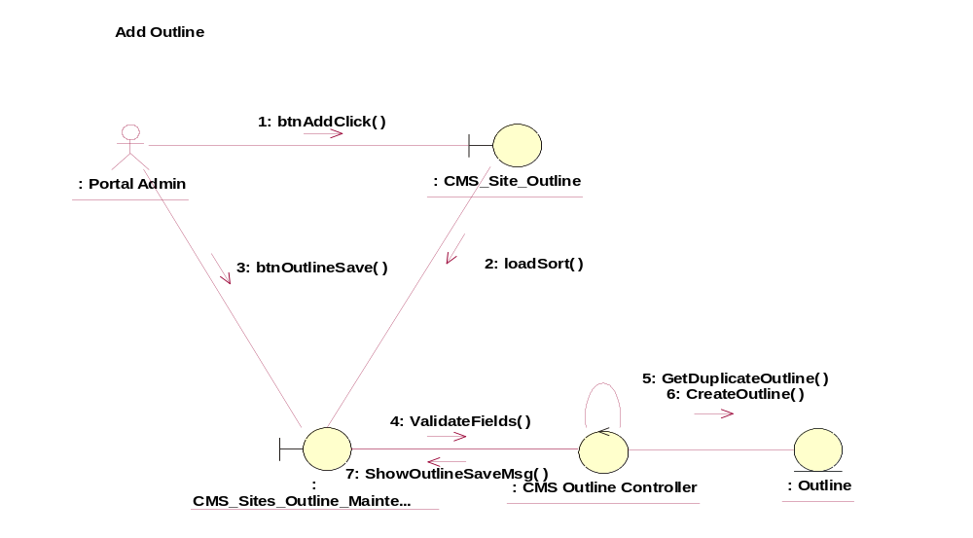

Participating Objects
: CMS_Site_Outline
This object will be used for creating the outline.
: CMS_Sites_Outline_Maintenance
This object will be used for creating/updating/deleting and viewing outlines by portal admin.
: CMS Outline Controller
This is the controller to validate the files and duplicate check and creation of the outline..
: Outline
This is the object to store the outline info.

Class Diagrams

Class Diagram for Add Outline
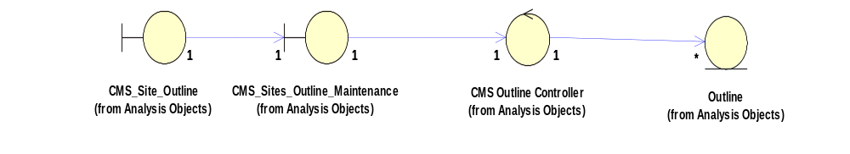

Derived Requirements
[enter the derived requirements here]

